Module 3: CloudWatch Alarms Assignment
Problem Statement:
You work for XYZ Corporation. To maintain the security of the AWS account and the resources you have been asked to implement a solution that can help easily recognize and monitor the different users. Also, you will be monitoring the machines created by these users for any errors or misconfigurations.
Tasks To Be Performed:
1. Create a CloudWatch billing alarm which goes off when the estimated charges go above $500.
2. Create a CloudWatch alarm which goes off to an Alarm state when the CPU utilization of an EC2 instance goes above 65%. Also add an SNS topic so that it notifies the person when the threshold is crossed.

Steps:
1. Create a CloudWatch billing alarm which goes off when the estimated charges go above $500.
AWS Billing CloudWatch EstimatedCharges Metric CloudWatch Alarm (Threshold > $500) Amazon SNS Topic Email Notification
- Select User setting Billing and cost Management:
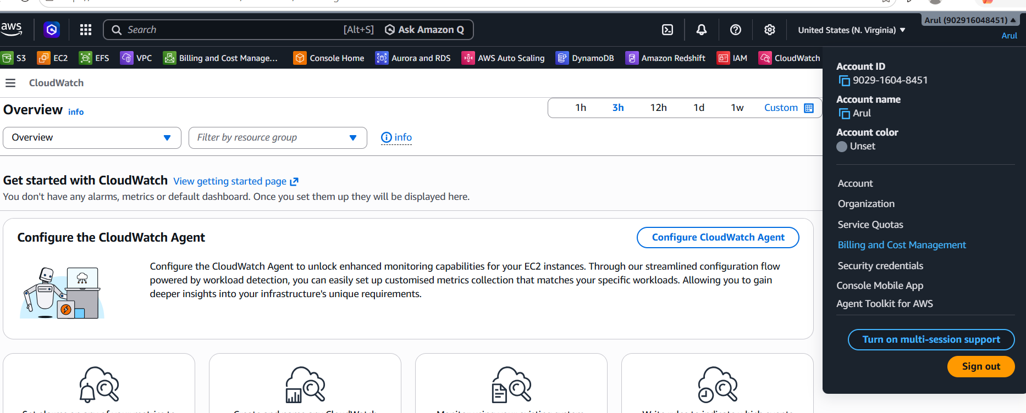
- Enable Cloud watch billing alerts under Billing Preferences:
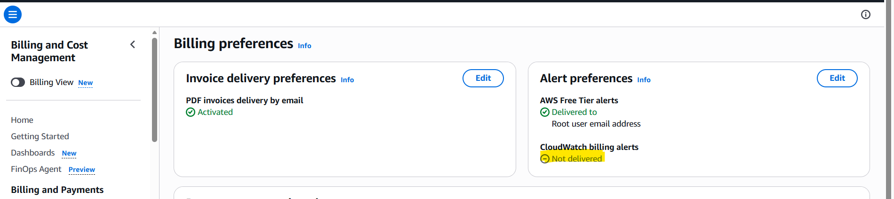

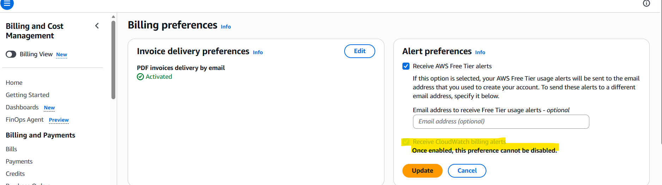
- Create a SNS topic: BillingAlaram
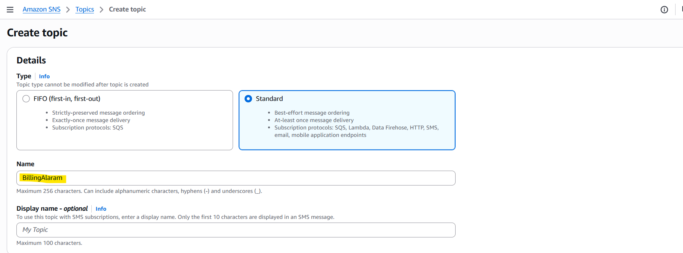
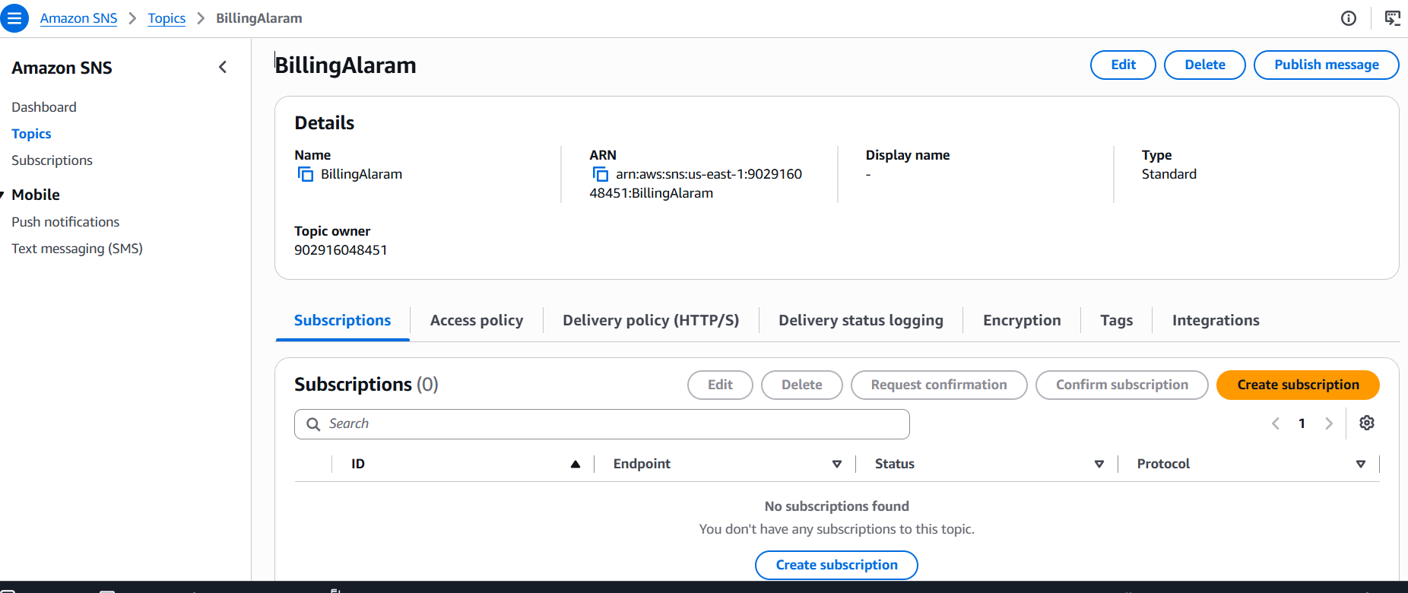
- Create subscription:
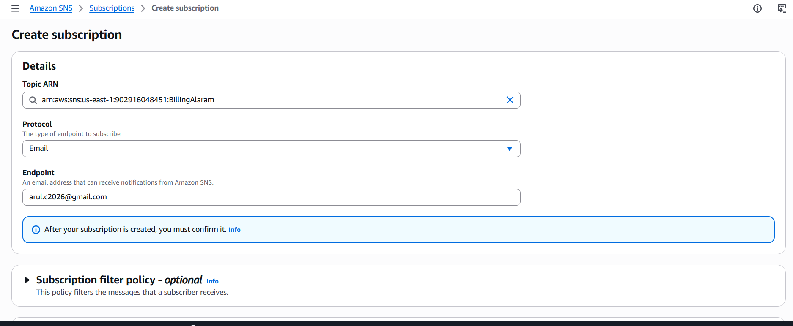
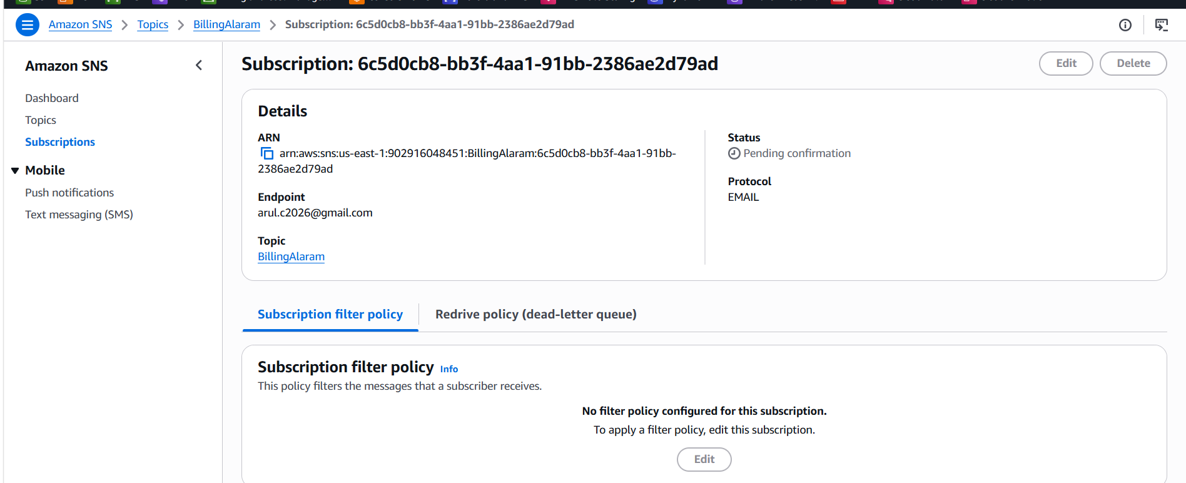
- Create the metrics Alarm:
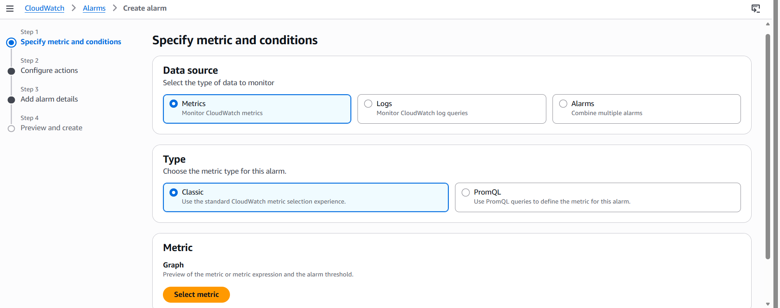
- Click on Select metric Billing Total Estimated Charge USD:
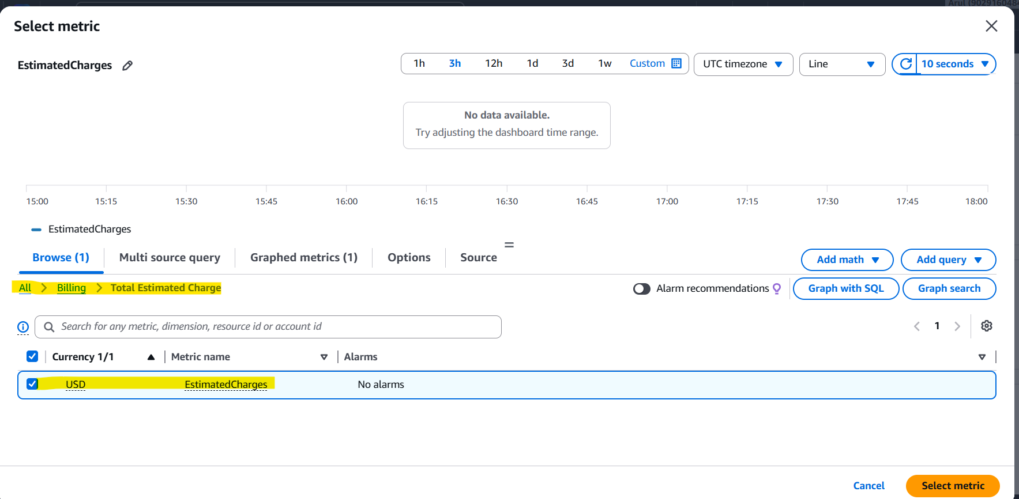
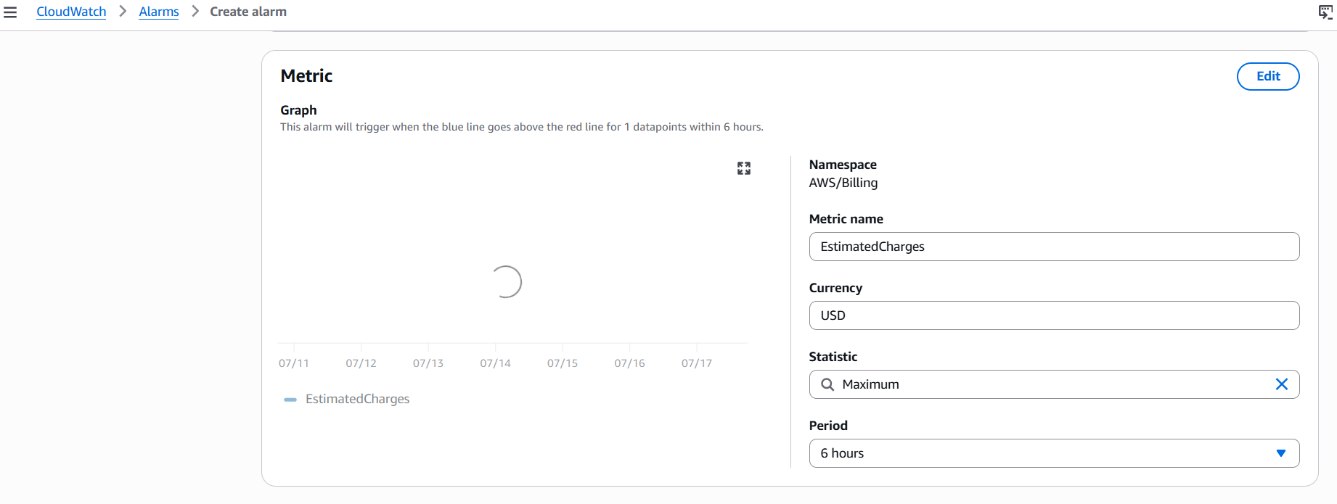
- Mention the threshold value as 500$.
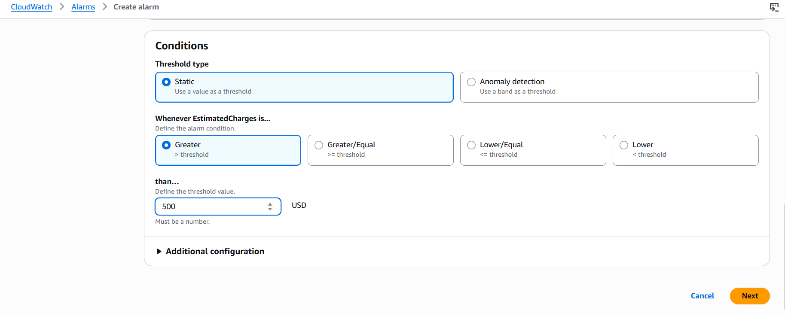
- Select the SNS topic:
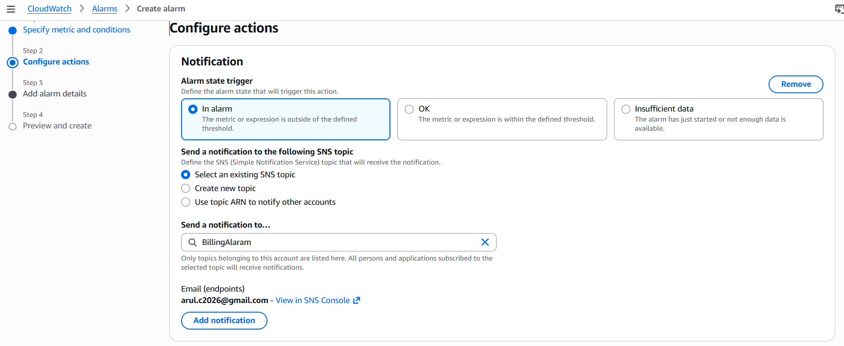
- Alarm Name: Billingabove500$
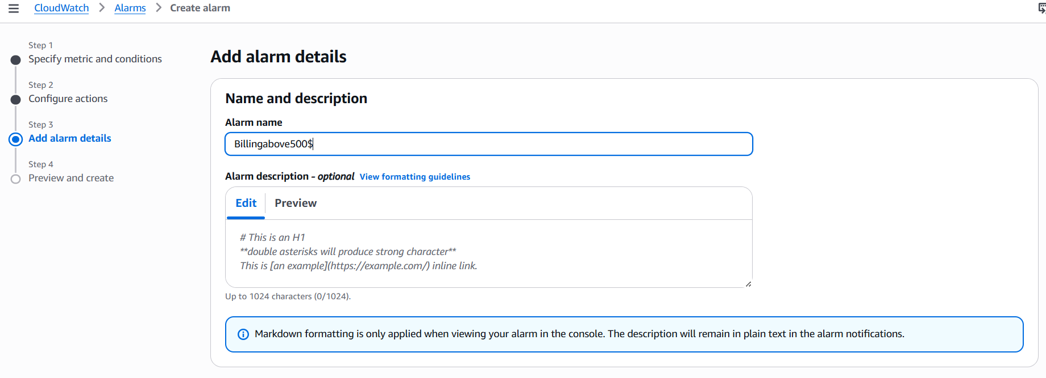
- Confirm the mail subscription:
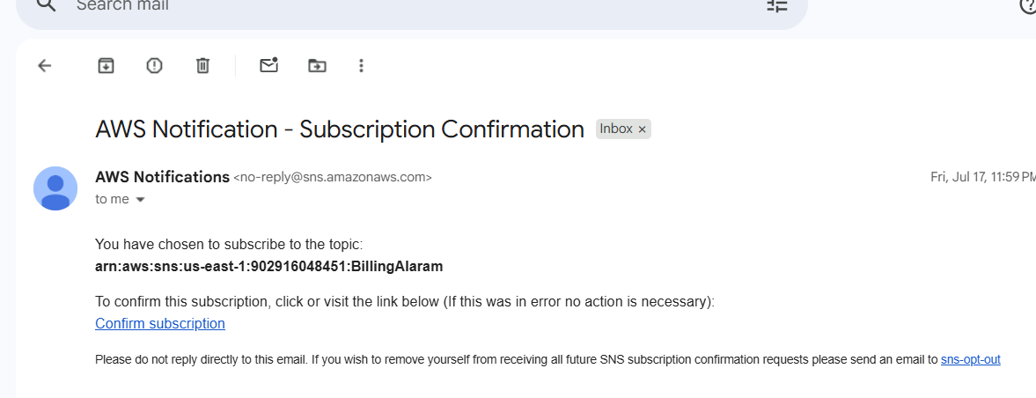
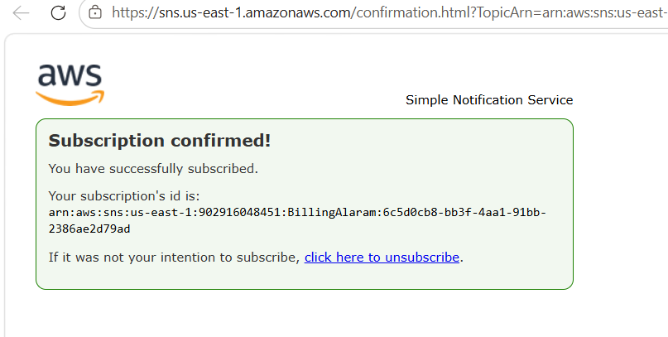
Billing Alarm created:
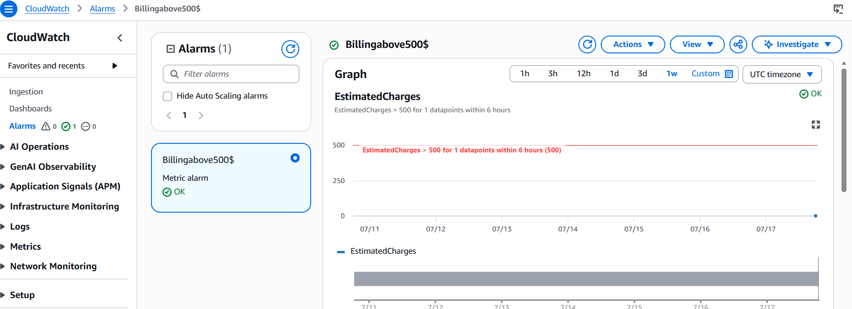
2. Create a CloudWatch alarm which goes off to an Alarm state when the CPU utilization of an EC2 instance goes above 65%. Also add an SNS topic so that it notifies the person when the threshold is crossed.
A. Create the topic: ec2cpuusage65above
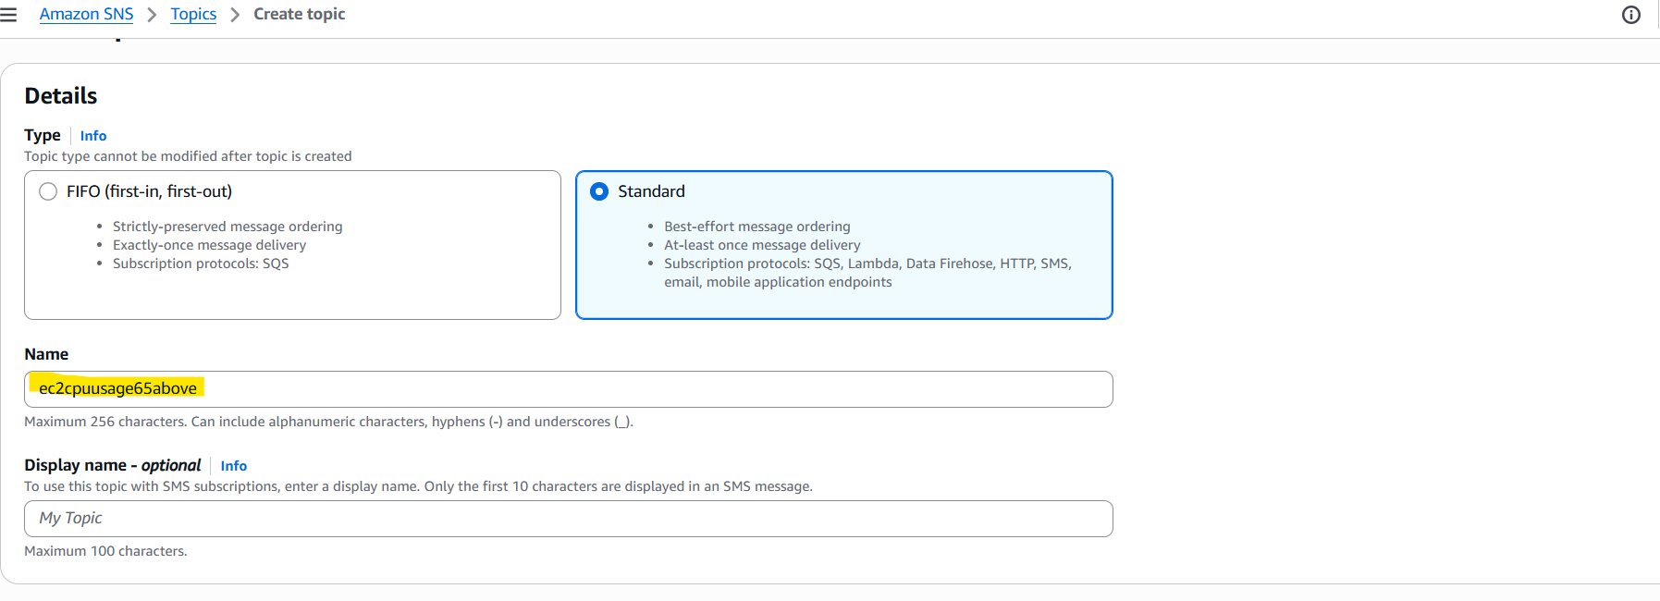
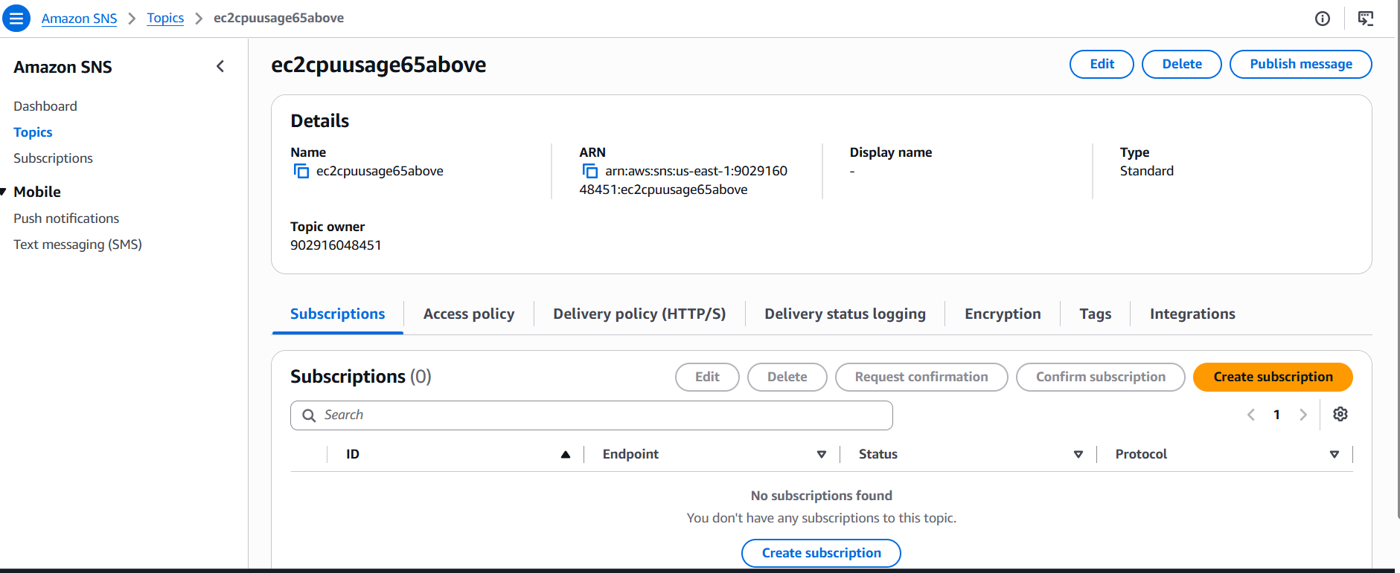
B. Add subscription and confirm:
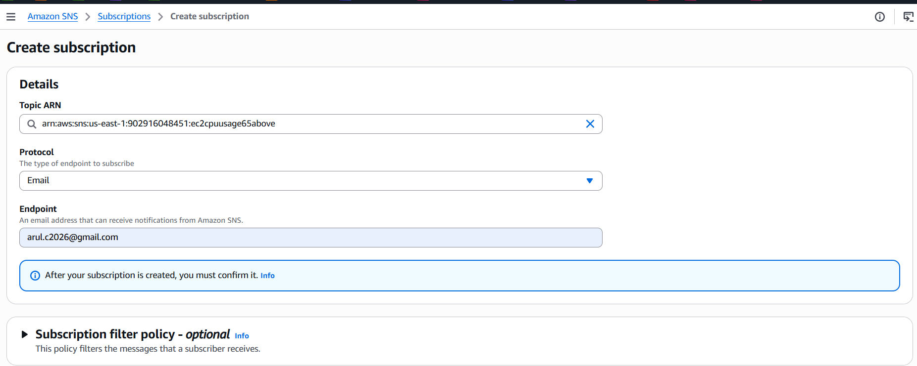
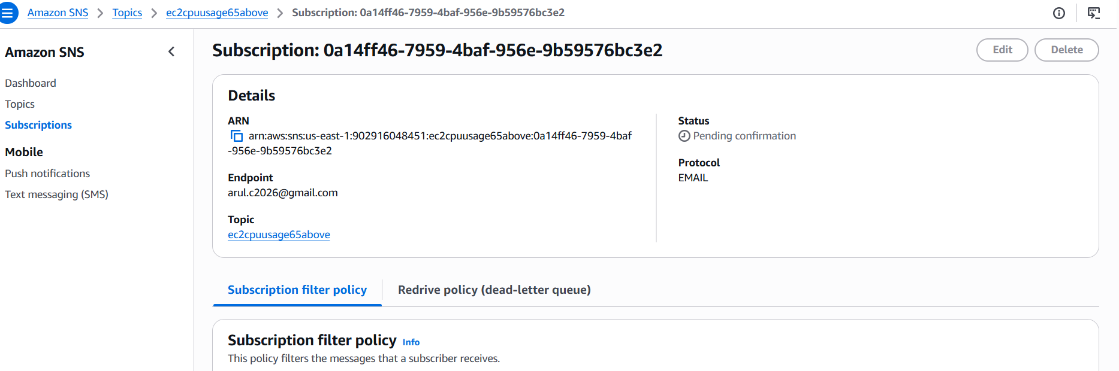
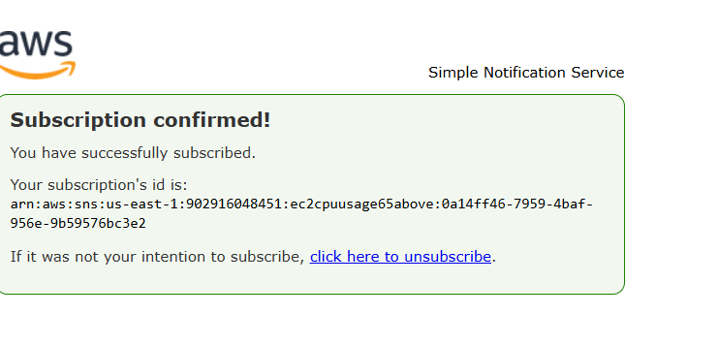
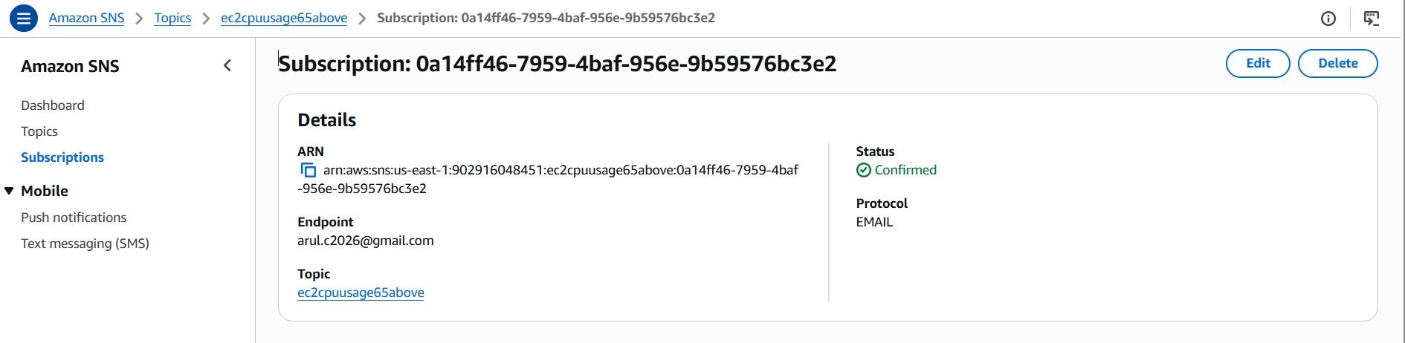
C. Create the Metric Alarm:
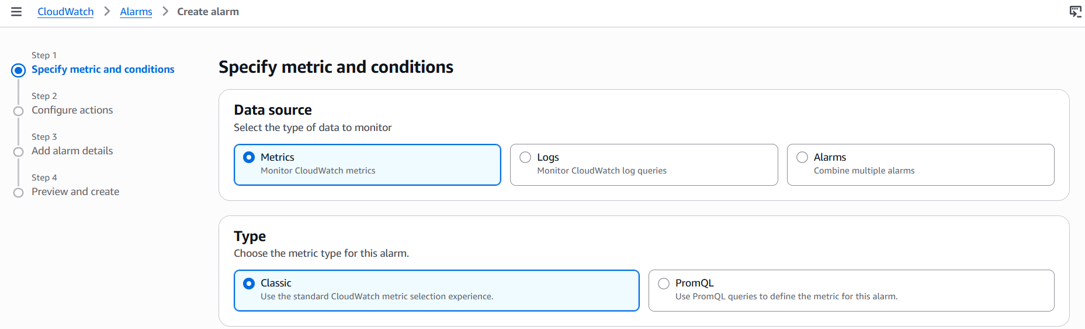
D. Mention the Metric threshold >65%
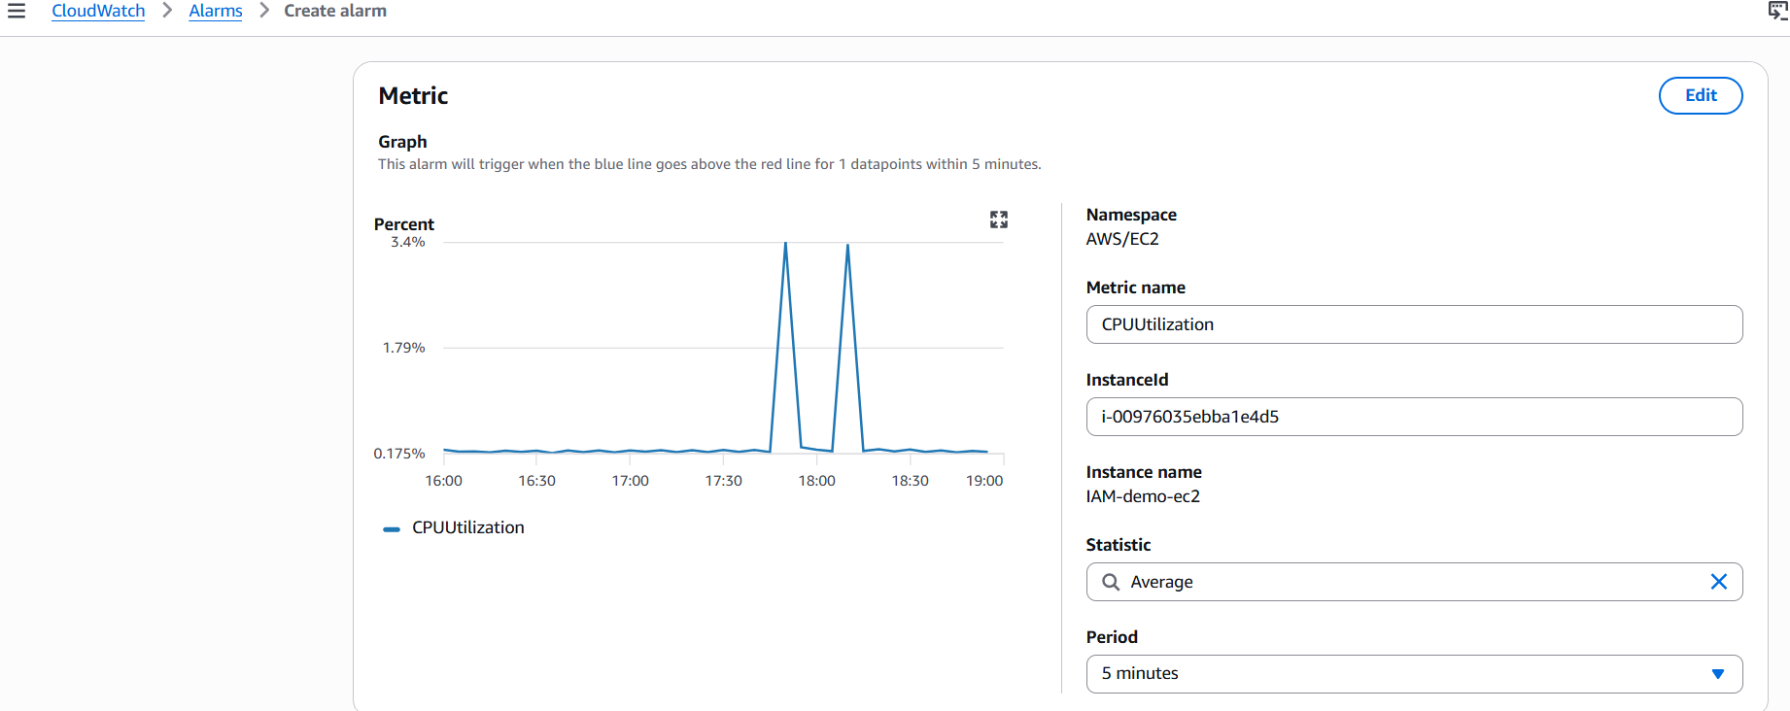
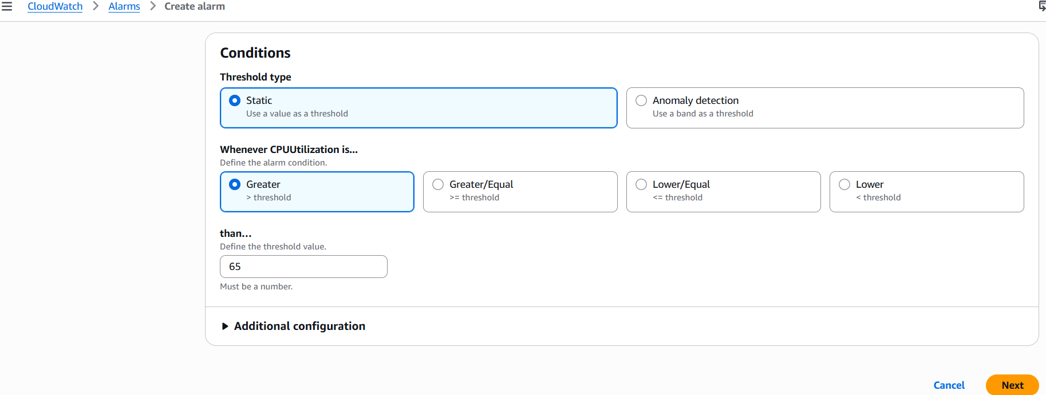
E. Create the Alarm: Select the SNS topic
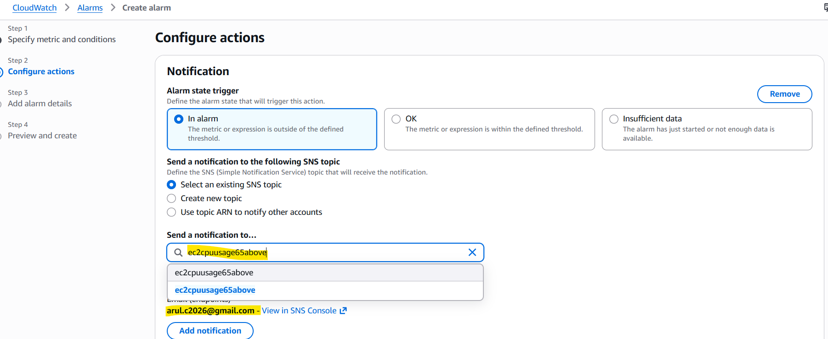
F. Add the alarm details:
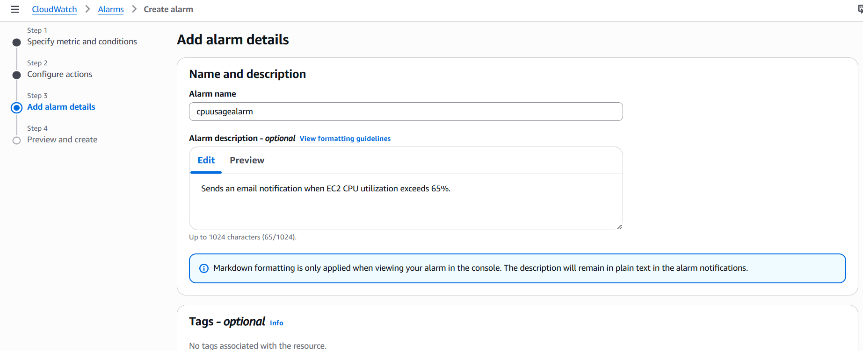
Validate the CPU usage alert:
Install the stress package and artificially initiate the load
#stress --cpu 2 --timeout 300
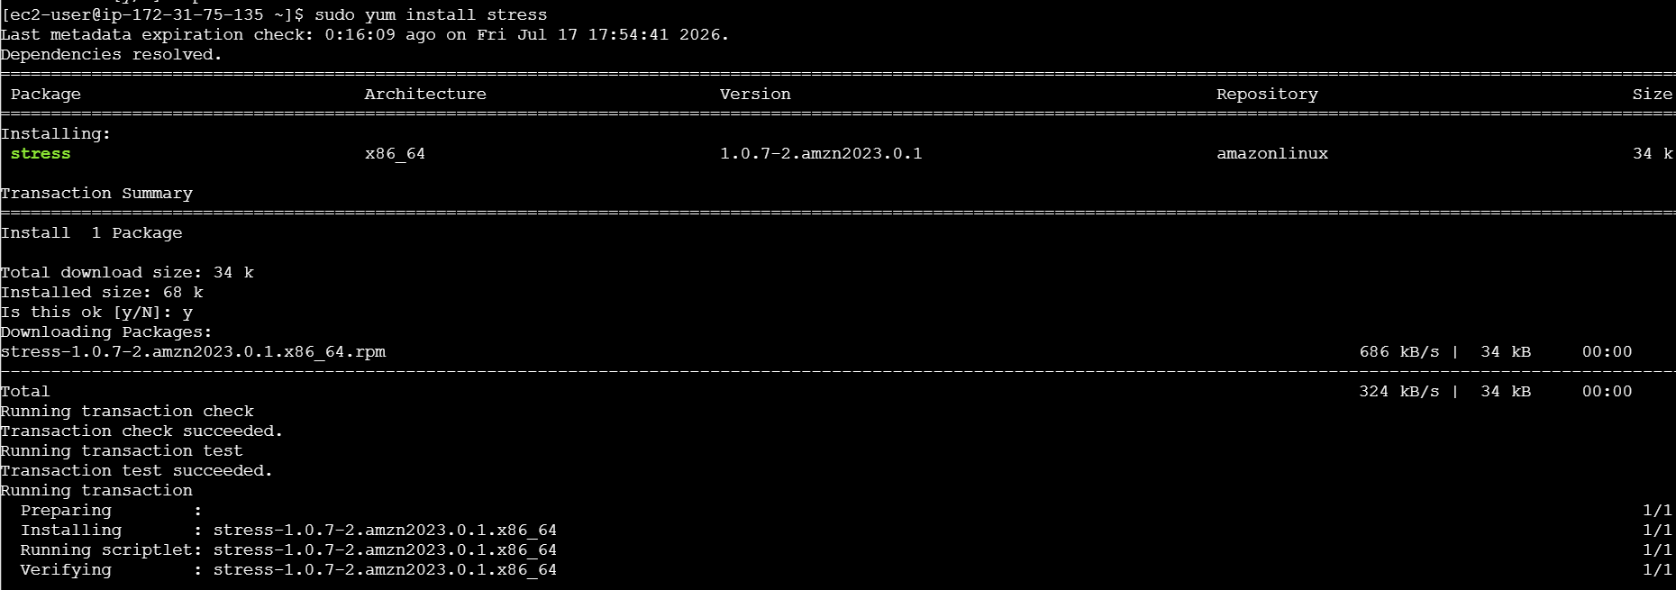
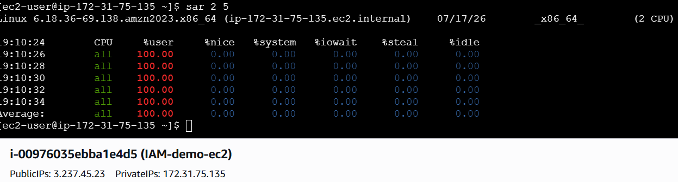
CPU usage is above threshold value:
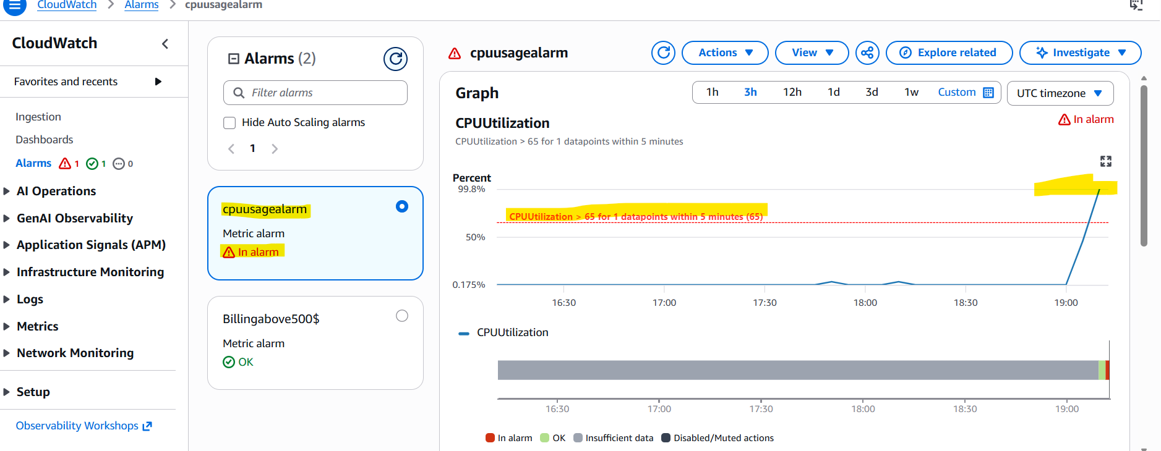
Received the mail alert for the CPU usage:
